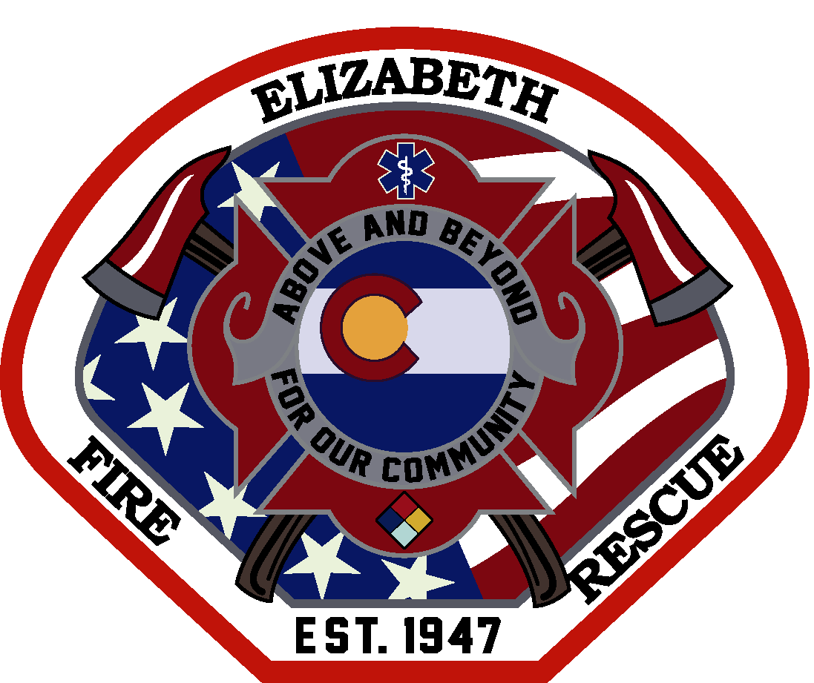

FIRE CHIEF RECRUITMENT
Candidate Supplemental Questions

To give the Elizabeth Fire Protection District a better sense of your communication skills and experience, please answer the following questions and include your name. Please limit your response to one page total.

NAME:

1) Elizabeth Fire Protection District is experiencing continued community growth while maintaining a strong organizational culture. Describe your leadership priorities during your first 18 months as Fire Chief and how you would balance organizational growth with preserving the values that make the District successful.

2) Stakeholders consistently expressed the desire for a Fire Chief who is visible, direct, and invested in both people and organizational development. Describe your leadership philosophy and provide an example of how you strengthened trust, improved culture, or led meaningful organizational change within your current or previous organization.

