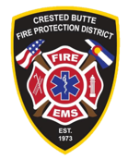

FIRE & EMS CHIEF RECRUITMENT
Candidate Supplemental Questions

To give the Crested Butte Fire Protection District a better sense of your communication skills and experience, please answer the following questions and include your name. Please limit each response to one paragraph, with the combined responses not to exceed one page.

NAME:

1) Leading the Next Chapter
How would you assess an already successful organization and determine what should be preserved, what should be refined, and what should change?

2) Combination Fire & EMS Leadership
Describe your experience and/or understanding of a diverse service delivery model and how you would ensure fire, EMS, and training each receive appropriate attention?

